

Booking ticket online

* **Faculty: Ho Hoan Kiem**
* **Batch:**
* **Team Member:**

1. Nguyen Duy Dat – SE63093
2. Bui Trung Hieu – SE62797
3. Le Minh Huy – SE62817

**Ho Chi Minh City, May 30, 2018**

Table of Contents

1. Review 1

* ***Problem Definition* ………………………………………………..04**
* ***Requirement Specification* ………………………….…………… 05**

1. Review 2

* ***Use Case Diagram* 10**
* ***Class Diagram* 13**
* ***Sequence Diagram* 16**

REVIEW 1

**Problem Definition**

1. **The Object Of The Project**

This project is aim at creation of a secure Booking ticket online system. This will be accessible to both customers who have a valid User Id and Password and who don’t have. This system provides the following facilities:

* Search for movies on show
* View schedules of movie in the selected date
* Book tickets online and get code of tickets through phone number or email
* Make online payment when booking ticket
* View and modify member profile
* View promotions detail

**Requirement Specification**

1. **Functional Requirements**

In this system, there are 4 kinds of users:

* Admin
* Cinema staff
* Member
* Guest

Following is 4 lists of functionalities of the system. More functionalities that you find appropriate can be added to this list.

## Admin Requirements

Introduction: Admins have ability and responsibility to directly manage the system such as manage staff, add a new movie into schedule and so on.

These are all requirements of the admin in the system:

* Admin must have a valid username and password to login to the system.
* After login, a form of admin’s workspace will be presented. That form contains 6 tags for 6 fields to be managed:
  + The list of cinema staves: admin can add a new staff, remove a staff when he/she quits the job.
  + The list of members: admin can check information of member, remove a member or contact to him/her.
  + The list of movies: admin can add new movies which will be shown in the cinema.
  + The list of promotions: admin can create promotions and launch them.
  + The list of rooms: admin can get information about each room and give the schedule accurately.
  + The list of schedules: admin can add new schedules, update the schedules.
  + The list of transactions: admin can find the transaction by booking code.
* Admin can logout when finishing his/her work.

## Cinema Staff Requirements

Introduction: Cinema Staff is one of four kinds of user in the System. Cinema staff have responsibility to stand at the ticket box, receive the booking code from customers, enter the code and print tickets.

These are all requirements of the staff in the system:

* Staff must have a valid username and password to login to the system.
* After login, a form of staff’s workspace will be presented. That form has a field to enter the booking code, check code so that I can check and print tickets for customer.
* Staff can logout when finishing his/her work.

## Member Requirements

Introduction: Each member has an account to login into the system and have right to take part in promotions as well as collect points for further favors.

These are all requirements of the member in the system:

* Member must have a valid username and password to login to the system.
* Member can view and update his/her profile.
* Member can check his/her points.
* Member can view movie schedule by movie.
* Member can view movie schedule by date.
* Member can view the price of ticket.
* Member can book tickets online. The process of booking ticket online includes choosing movie, choosing time, choosing seats, entering promotion code (only for member), making payment online through Internet Banking of E-wallet. After booking successfully, the booking code is sent to customer through phone number and email.
* Member can logout when he/she finishes his/her work.
* Member can give feedbacks to the system.

## Guest Requirements

Introduction: Guests are people who just visit the system but don’t have accounts. A guest can book tickets without having to be a member. If a guest wants to be a member, he/she can register.

These are all requirements of the guest in the system:

* Guest don’t have to login to the System, there is a button named “Continued as a guest” for those who don’t want to be a member.
* Guest can view movie schedule by movie.
* Guest can view movie schedule by date.
* Guest can view the price of ticket.
* Guest can book tickets online. The process of booking ticket online includes choosing movie, choosing time, choosing seats, making payment online through Internet Banking of E-wallet. After booking successfully, the booking code is sent to customer through phone number and email.
* Guest can register to be a member.
* Guest can give feedback to the system.

# Hardware/ Software Requirements

By adding new technologies such as ASP.NET 3.5, AJAX, Web Service and 3-tier architecture, the web site becomes more interactive with users, security and easily updated.

1. **System Requirement**

* **For Users**
  + **Hardware**
    - CPU: Pentium IV 2.0 GHz or higher
    - RAM: 512 MB or higher
  + **Software**
    - OS: Windows 7/XP Professional/Server 2003…
    - Browser: Internet Explorer 8.0 or higher
* **For Software Developers**
  + **Hardware**
    - CPU: Pentium IV 2.0 GHz or higher
    - RAM: 512 MB or higher
  + **Software**
    - OS: Windows XP Professional/Server 2003…
    - Environment: Microsoft .NET Framework 3.5 or higher
    - Database Management System: Microsoft SQL Server 2008 or higher
    - IDE: Microsoft Visual Studio 2010 or higher
    - Web Server: Internet Information Services (IIS) JSP / Servlets Dev. Kit

|  |  |  |
| --- | --- | --- |
| **Date: May 30, 2018** | **Prepared by Project Group 4**  **Team Leader:** | **Approved by**  **Mr Ho Hoan Kiem** |
| **Signature** |  |  |

REVIEW 2

**USE CASE DIAGRAM**

**Admin:**

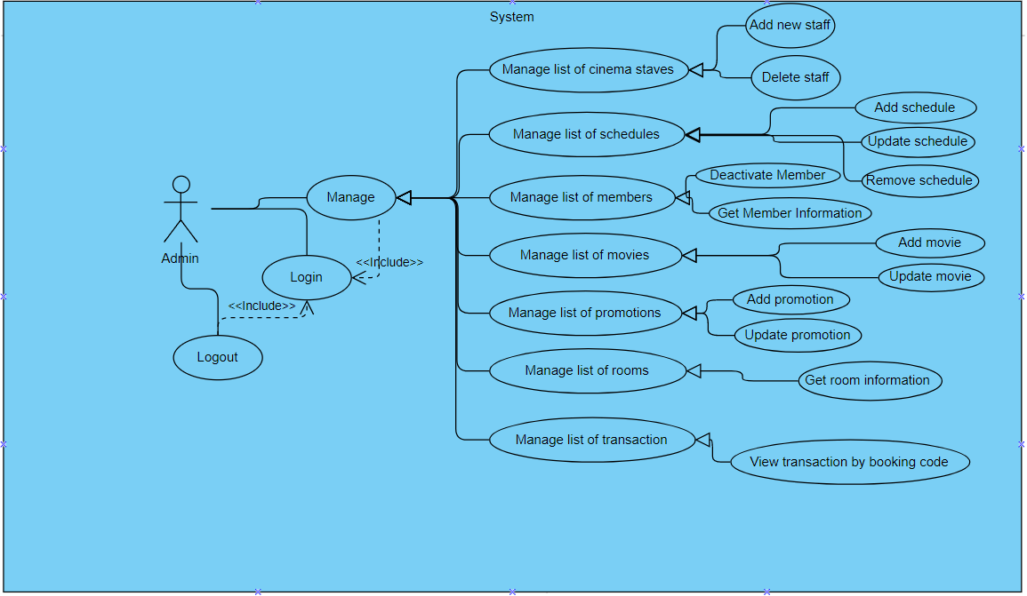

**Cinema staff:**

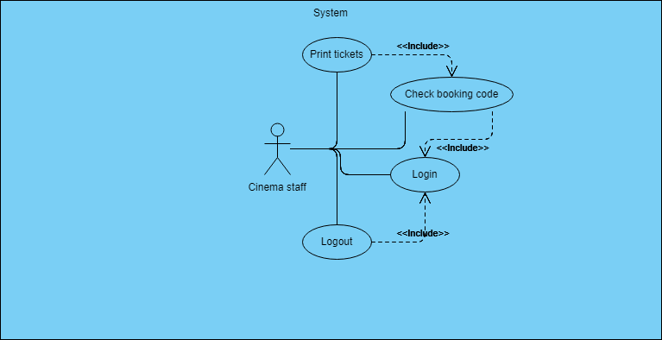

**Member:**

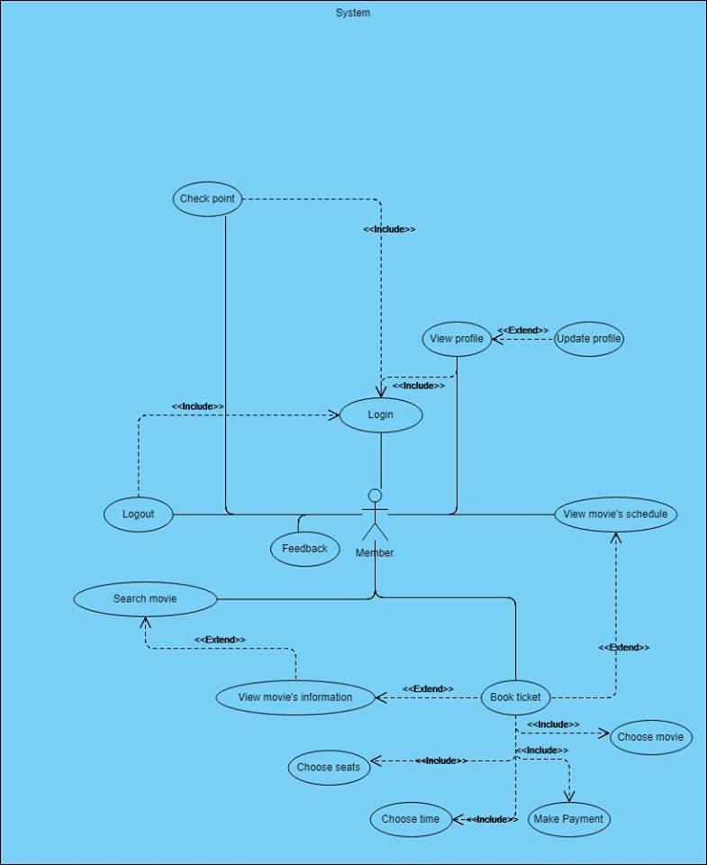

**Guest:**

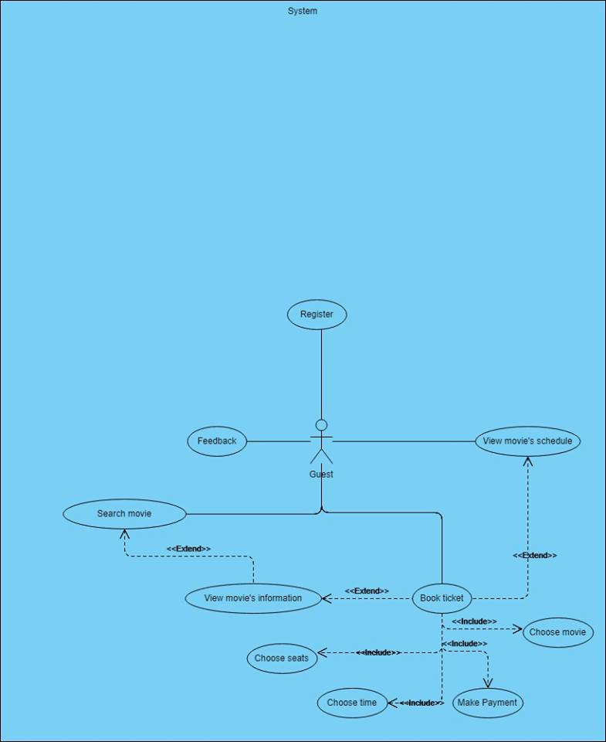

**Class Diagram**

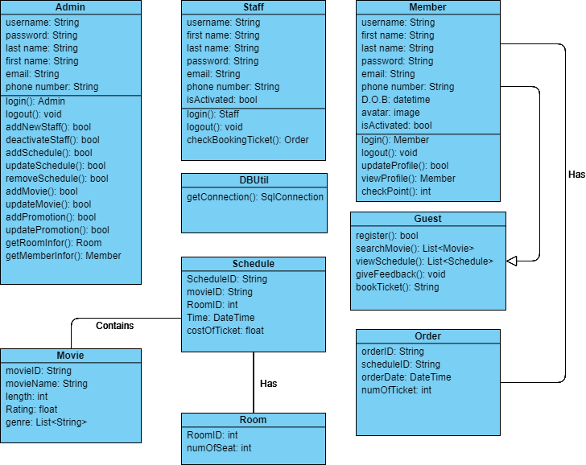

**Sequence Diagram**

1. **Admin**

Login

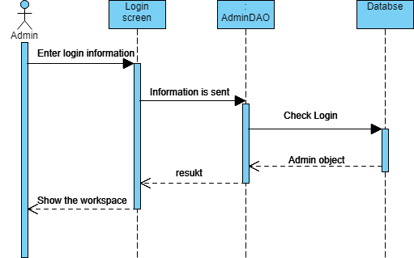

Logout

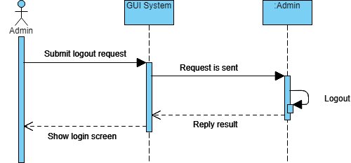

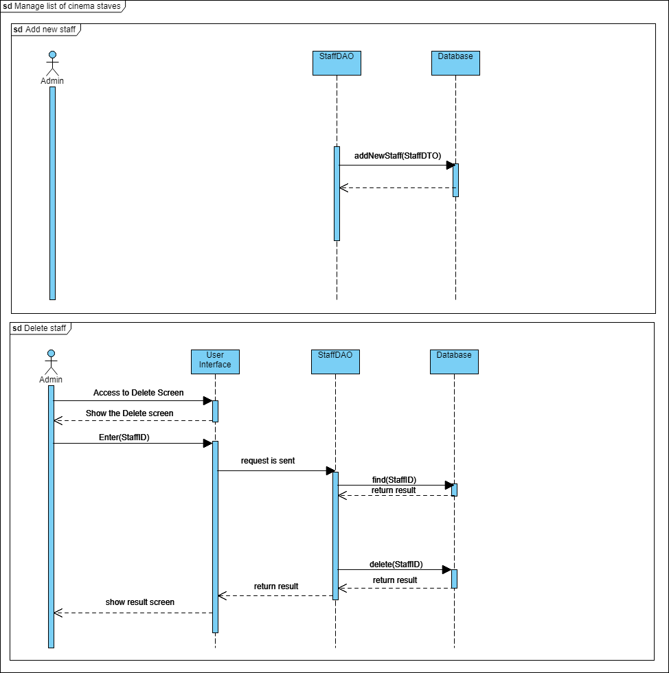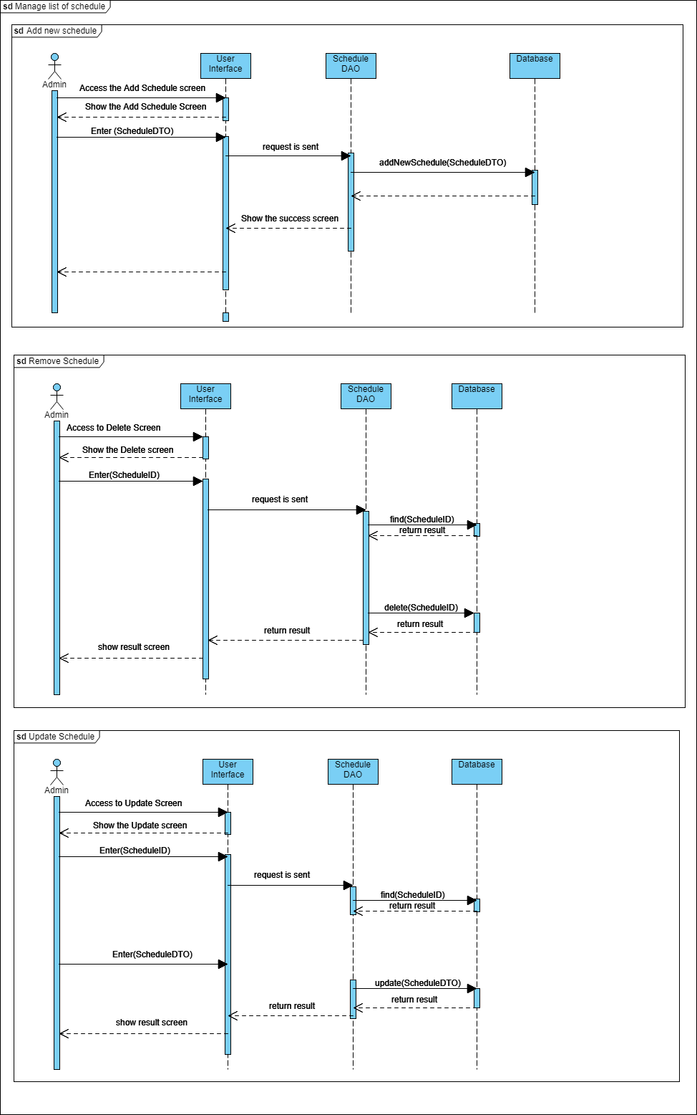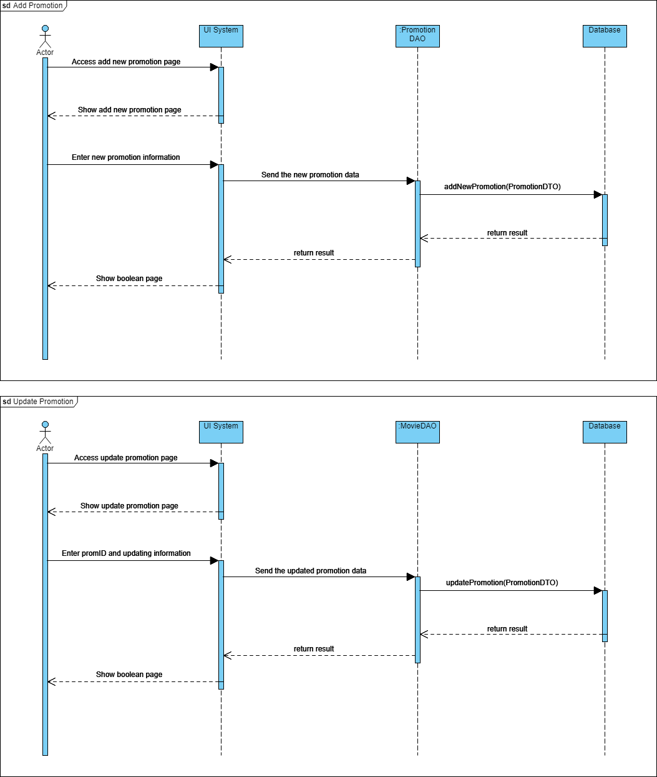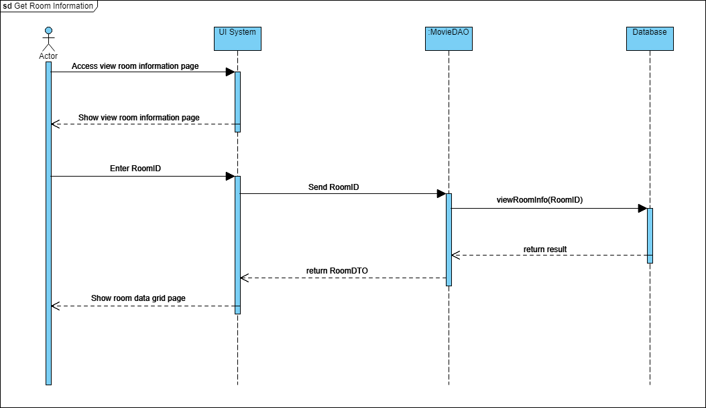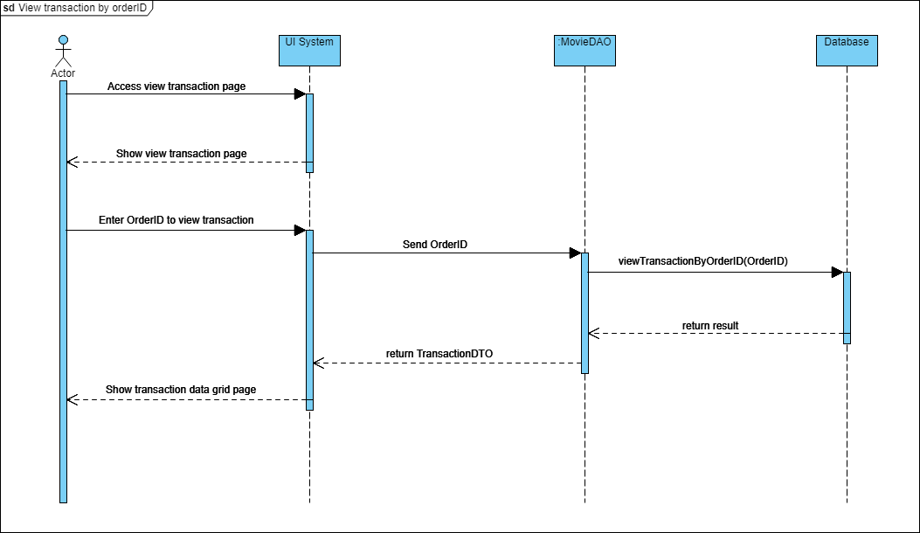

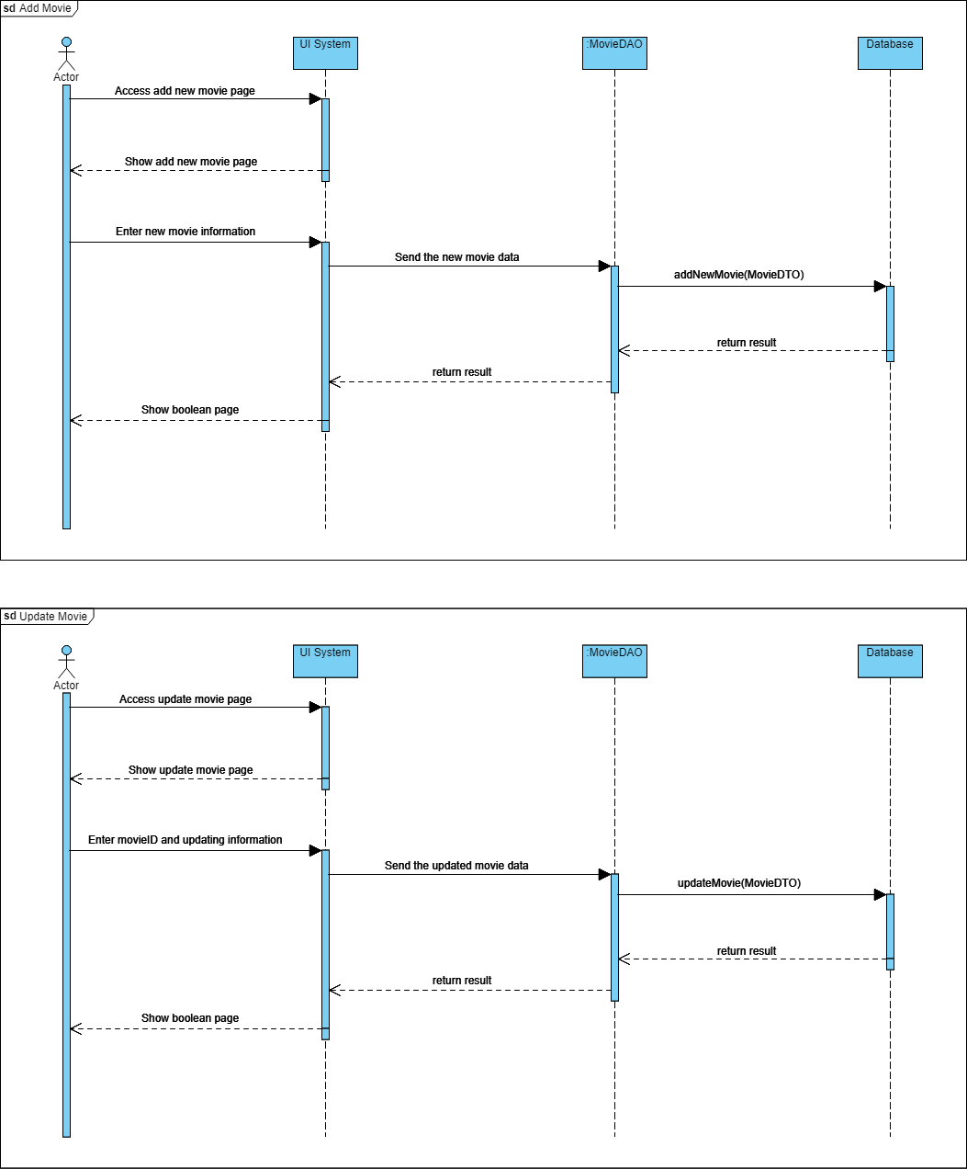

1. **Staff**

Login

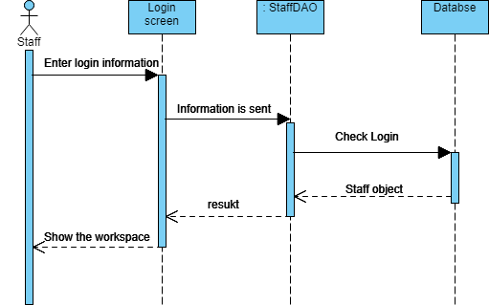

Logout

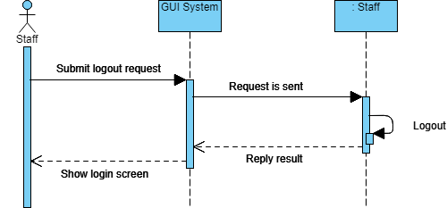

Check booking code

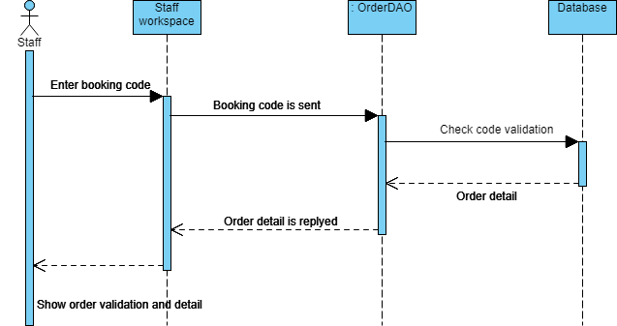

1. **Member**

Login

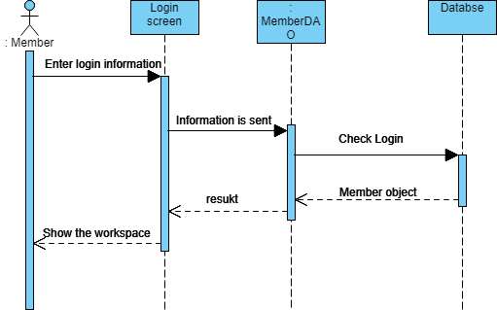

Logout

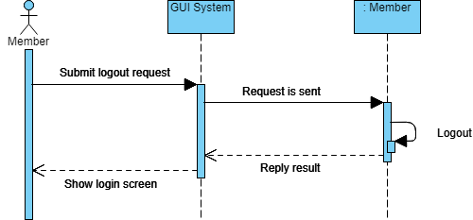

View profile

Check point

Update profile

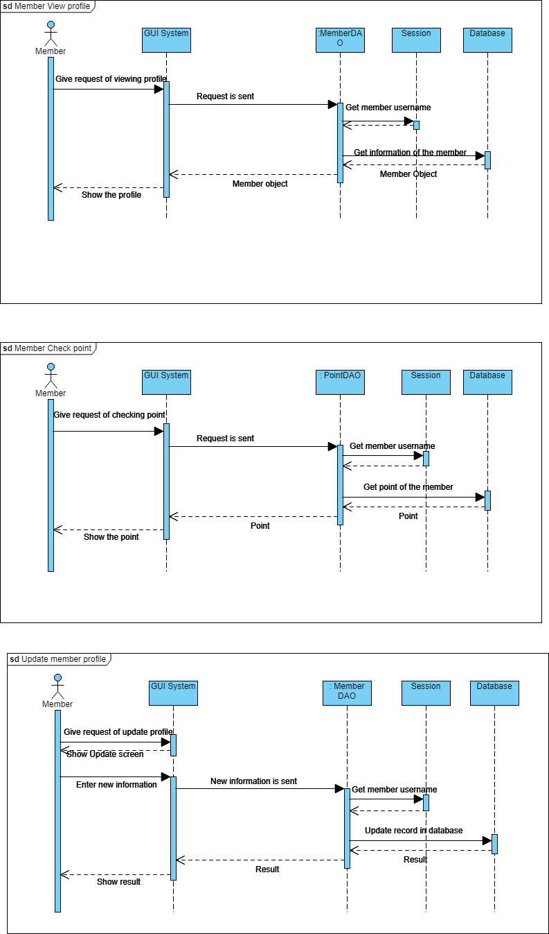

1. **Guest / Member**

